|  |  |  |
| --- | --- | --- |
| JALAN SINGOSARI 2 A | Telp. | (62) 024 - 8416771 |
| S E M A R A N G |  | (62) 024 - 8311527 |
| KODE POS 50242 |  |  |

N O T A D I N A S

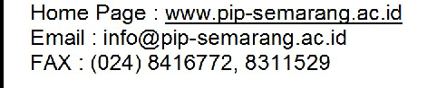

**KEMENTERIAN PERHUBUNGAN**

**BADAN PENGEMBANGAN SUMBER DAYA MANUSIA PERHUBUNGAN**

**POLITEKNIK ILMU PELAYARAN SEMARANG**

Nomor : PIP.Smg-20

Kepada Yth : Direktur Politeknik Ilmu Pelayaran Semarang Dari : Kepala Unit Laboratorium Dan Simulator

Perihal : Permohonan Permintaan Bahan Praktek Taruna D IV pembentukan

1. Berdasarkan Program Kerja Unit Laboratorium Dan Simulator Tahun Anggaran 2020.

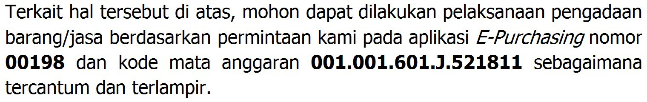2.

3. Demikian disampaikan, atas perhatian dan kerjasamanya kami ucapkan terima kasih.

Semarang, 19 Februari 2020 KEPALA UNIT LABORATORIUM DAN SIMULATOR

 

1. Pejabat Pembuat Komitmen.
2. Pejabat Pengadaan.

Penata Tk I, III/d

NIP. 19760709 199808 1 001

**DISPOSISI**

|  |  |  |  |  |  |  |  |  |  |
| --- | --- | --- | --- | --- | --- | --- | --- | --- | --- |
|  | | | **LAMPIRAN NOTA DINAS** | | | | | | |
| **UNIT LAYANAN PENGADAAN BARANG/JASA** | | | | | | | | | |
| No | | : | 00045/ND.1472 PIP.Smg-20 |  |  |  | |  |  |
| Dari | | : | Kepala Unit Laboratorium Dan Simulator |  |  |  | |
| Perihal | | : | Permohonan Permintaan ATK Lab, Sim |  |  |  | |
| **DAFTAR BARANG** | | | | | | | | | |
| **No** | **Nama Barang** | | | | | | **Volume** | | **Spesifikasi** |
| **Jumlah** | **Satuan** |
| 1 | Kertas A4 | | | | | | 225 | Rem |  |
| 2 | Map Plastil L | | | | | | 350 | Buah |  |
| 3 | Map Tanda Tangan | | | | | | 180 | Buah |  |
| 4 | Bolpoin BOXI | | | | | | 9 | Lusin |  |
| 5 | Tinta EPSEN 664 Warna Hitam | | | | | | 180 | Buah |  |
| 6 | Tinta EPSEN 664 Warna Kuning | | | | | | 135 | Buah |  |
| 7 | Tinta EPSEN 664 Warna Merah | | | | | | 135 | Buah |  |
| 8 | Tinta EPSEN 664 Warna Biru | | | | | | 135 | Buah |  |
| 9 | Mouse Pad | | | | | | 30 | Buah |  |
| 10 | Battery AA | | | | | | 270 | Buah |  |
| 11 | Battery AAA | | | | | | 360 | Buah |  |
| 12 | C-Mos Battery | | | | | | 50 | Buah |  |
| 13 | Double Tape Tebal Hitam | | | | | | 36 | Buah |  |
| 14 | Bolpoin Standler | | | | | | 10 | Lusin |  |
| 15 | Lakban Kertas 3 Cm | | | | | | 50 | Buah |  |
| 16 | Steples Kecil | | | | | | 9 | Buah |  |
| 17 | Steples Besar | | | | | | 9 | Buah |  |
| 18 | Isi Steples Kecil | | | | | | 63 | Dos |  |
| 19 | Isi Steples Besar | | | | | | 45 | Dos |  |
| 20 | Buku Tulis Batik Besar | | | | | | 63 | Buah |  |
| 21 | Spidol WB Warna Hitam | | | | | | 27 | Lusin |  |
| 22 | Spidol WB Warna Merah | | | | | | 18 | Lusin |  |
| 23 | Spidol WB Warna Hijau | | | | | | 18 | Lusin |  |
| 24 | Spidol WB Warna Biru | | | | | | 18 | Lusin |  |
| 25 | Plastik Laminating | | | | | | 6 | Rim |  |
| 26 | Kertas Stiker | | | | | | 6 | Rim |  |
|  | | | | | | | | | |
| 27 | Penghapus Papan Tulis | | | | | | 65 | Buah |  |
| 28 | Isi mesin Labeling | | | | | | 8 | Buah |  |
|  |  | | | | | |  |  |  |

Semarang, 1 Juli 2020

KEPALA UNIT LABORATORIUM DAN SIMULATOR



Penata Tk I, III/d

NIP. 19760709 199808 1 001