|  |  |  |
| --- | --- | --- |
| JALAN SINGOSARI 2 A | Telp. | (62) 024 - 8416771 |
| S E M A R A N G |  | (62) 024 - 8311527 |
| KODE POS 50242 |  |  |

N O T A D I N A S

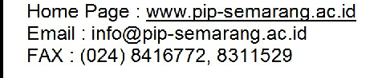

**KEMENTERIAN PERHUBUNGAN**

**BADAN PENGEMBANGAN SUMBER DAYA MANUSIA PERHUBUNGAN**

**POLITEKNIK ILMU PELAYARAN SEMARANG**

Nomor : PIP.Smg-20

Kepada Yth : Direktur Politeknik Ilmu Pelayaran Semarang Dari : Kepala Unit Laboratorium Dan Simulator

Perihal : Permohonan Permintaan Bahan Praktek Taruna D IV pembentukan

1. Berdasarkan Program Kerja Unit Laboratorium Dan Simulator Tahun Anggaran 2020.

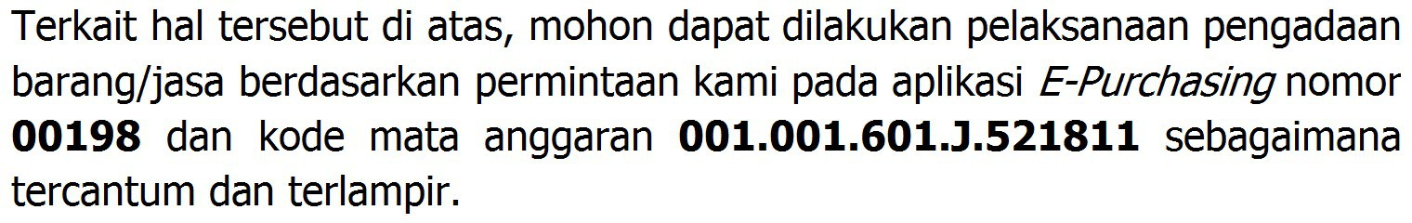2.

3. Demikian disampaikan, atas perhatian dan kerjasamanya kami ucapkan terima kasih.

Semarang, 19 Februari 2020 KEPALA UNIT LABORATORIUM DAN SIMULATOR

 

1. Pejabat Pembuat Komitmen.
2. Pejabat Pengadaan.

Penata Tk I, III/d

NIP. 19760709 199808 1 001

**DISPOSISI**

|  |  |  |  |  |  |  |  |  |  |
| --- | --- | --- | --- | --- | --- | --- | --- | --- | --- |
|  | | | **LAMPIRAN NOTA DINAS** | | | | | | |
| **UNIT LAYANAN PENGADAAN BARANG/JASA** | | | | | | | | | |
| No | | : | 00198/ND..................... |  |  |  | |  |  |
| Dari | | : | Kepala Unit Laboratorium Dan Simulator |  |  |  | |
| Perihal | | : | Permohonan Permintaan Bahan Praktek Taruna | D | IV | pembentukan | |
| **DAFTAR BARANG** | | | | | | | | | |
| **No** | **Nama Barang** | | | | | | **Volume** | | **Spesifikasi** |
| **Jumlah** | **Satuan** |
| 1 | Besi Cor Ukuran 14” | | | | | | 10 | Batang | Standar SNI |
| 2 | Besi Cor Ukuran 12” | | | | | | 10 | Batang | Standar SNI |
| 3 | Besi Hollo Ukuran 4x4 | | | | | | 10 | Batang | Standar SNI |
| 4 | Besi Hollo Ukuran 4x2 | | | | | | 10 | Batang | Standar SNI |
| 5 | Besi Pejal 1” | | | | | | 5 | Batang |  |
| 6 | Besi Pejal 1 ½” | | | | | | 5 | Batang |  |
| 7 | Besi Siku 4x4 | | | | | | 10 | Batang | Standar SNI |
| 8 | Besi Siku 3x3 | | | | | | 10 | Batang | Standar SNI |
| 9 | Besi Setrip | | | | | | 15 | Batang | Ukuran lebar 2 cm |
| 10 | Mata Gerinda Potong Tangan | | | | | | 50 | Buah | Ukuran 105x1,2x16mm |
| 11 | Mata Gerinda Potong Duduk | | | | | | 10 | Buah | Ukuran 14” |
| 12 | WD 40 | | | | | | 30 | Buah |  |
| 13 | Mata Pisau Frais | | | | | | 15 | Buah | Ukuran 4f 12x12x30x90 |
| 14 | Elektroda rb 26 | | | | | | 8 | Dos | Ukuran 20mm |
| 15 | Elektroda rb 26 | | | | | | 8 | Dos | Ukuran 26mm |
| 16 | Elektroda rb 26 | | | | | | 4 | Dos | Ukuran 32mm |
| 17 | Isi Ulang Tabung Oksigen | | | | | | 3 | Tabung |  |
| 18 | Isi Ulang Tabung Aceteline | | | | | | 2 | Tabung |  |
| 19 | Isi Ulang Tabubf Gas Argon | | | | | | 2 | Tabung |  |
| 20 | Tap and Snai | | | | | | 15 | Set |  |
| 21 | Majun | | | | | | 50 | Kg |  |
| 22 | Mata Gergaji Tangan | | | | | | 100 | Buah |  |
| 23 | Mata Pahat Bubut | | | | | | 6 | Dus |  |
| 24 | Tungsten Las Tig | | | | | | 5 | Buah |  |
| 25 | Kawat las Tig | | | | | | 2 | Dos |  |
| 25 | Besi Kanal C | | | | | | 10 | Batang | Ukuran 100x50x2 mm |
| 27 | Sarung Tangan kain | | | | | | 24 | Lusin |  |
| 27 | Kaca Mata Las Automatis | | | | | | 10 | Buah |  |
| 28 | Boiler Water Treatment | | | | | | 15 | Liter |  |
| 29 | Earmuff Protection | | | | | | 30 | Buah | Satandar SNI |
| 30 | Mesin Las Portable | | | | | | 1 | Set |  |
| 31 | Senter Cas | | | | | | 3 | Buah |  |

Semarang, 19 Februari 2020

KEPALA UNIT LABORATORIUM DAN SIMULATOR



Penata Tk I, III/d

NIP. 19760709 199808 1 001